# Exercise-1

Design a web page using four different image files ‘image1.jpg’, ‘image2.jpg’, ‘image3.jpg’ and ‘image4.png’ according to the following specifications.

* Use a border 5px for ‘image1.jpg’.
* Resize the width and height of ‘image2.jpg’ 100 pixels each. Use anchor tag on this image and open original image.
* Align ‘image3.jpg” to either left or right side
* Leave space of 50px horizontally and vertically in ‘image4.png’
* align the text with respect to the images so as to obtain the appropriate output

CODE

<!DOCTYPE html>

<html>

<head>

<title> image</title>

</head>

<body >

<img src="C:\Users\dipak\Desktop\labwork6\week6\pic.jpg" border=5>

<img src="C:\Users\dipak\Desktop\labwork6\week6\pic2.jpg" width="100px" height="100px">

<img src="C:\Users\dipak\Desktop\labwork6\week6\pic3.jpg" align=:right">

<img src="C:\Users\dipak\Desktop\labwork6\week6\_DSC3687.JPG" hspace="50px" vspace="50px" height="400px" width="250px">

</body>

</html

OUTPUT

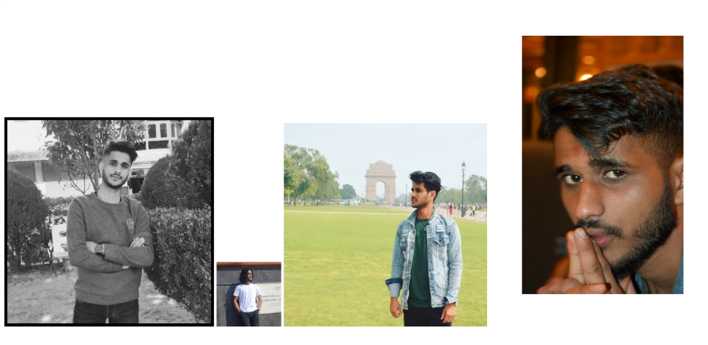

# Exercise 2

Create a document home.html with two links to an external document (about.html). The first link should lead to the beginning of the about.html. The second link should lead to a particular section Contact information in the about.html.

home.html should also contain a google logo of size 400px X 100px. On clicking this image, it should redirect to www.google.com

CODE

A<html>

<head>

<title> Links </title>

<a href="https://www.google.com">

<image src="C:\Users\dipak\Desktop\labwork6\week6\download.jpg" width="10%"

height="15%"></a>

</head>

<body>

<div>

<H1> welcome to my home page!!! <H1> <BR>

<a href="about.html">index</a>

</body>

OUTPUT

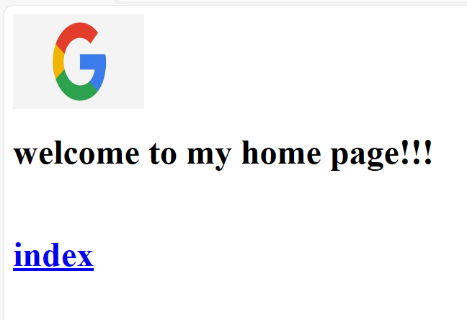

# Exercise 3

Create a Web page giving the following Bus details.

Place a border for the table and use cell padding to present the cell data with clarity.

Align the table in the center of the screen. Use a caption saying ‘Bus Sewa Time Table and Fare List’.

CODE

<html>

<head><title>2</title></head>

<body>

<table border="3" cellspacing="1" cellpadding="5">

<tr>

<td rowspan="2" align="center" bgcolor="#607BFE">Name of bus</td>

<td rowspan="2" align="center" bgcolor="#607BFE">Place</td>

<td rowspan="2" align="center" bgcolor="#607BFE">Destination</td>

<td colspan="2" align="center" bgcolor="#607BFE">Time</td>

<td rowspan="2" align="center" bgcolor="#607BFE">Fare</td>

</tr>

<tr>

<td align="center" bgcolor="#607BFE">arrival</td>

<td align="center" bgcolor="#607BFE">departure</td>

</tr>

<tr>

<td>western express</td>

<td>kathmandu</td>

<td>nepalgunj</td>

<td>07:30</td>

<td>08:00</td>

<td>Rs. 989.00</td>

</tr>

<tr>

<td>manakamana bus sewa</td>

<td>kathmandu</td>

<td>manakamana</td>

<td>09:00</td>

<td>10:15</td>

<td>Rs. 450.00</td>

</tr>

<tr>

<td>Buddha Express</td>

<td>kathmandu</td>

<td>butwal</td>

<td>11:30</td>

<td>12:25</td>

<td>Rs. 645.05</td>

</tr>

<tr>

<td>Baba Tourist Express</td>

<td>kathmandu</td>

<td>Pokhara</td>

<td>7:30</td>

<td>8:00</td>

<td>Rs. 756.00</td>

</tr>

<tr>

<td>Purba Express</td>

<td>kathmandu</td>

<td>Biratnagar</td>

<td>16:00</td>

<td>17:30</td>

<td>Rs. 345.00</td>

</tr>

</table>

</body>

</html>

OUTPUT

